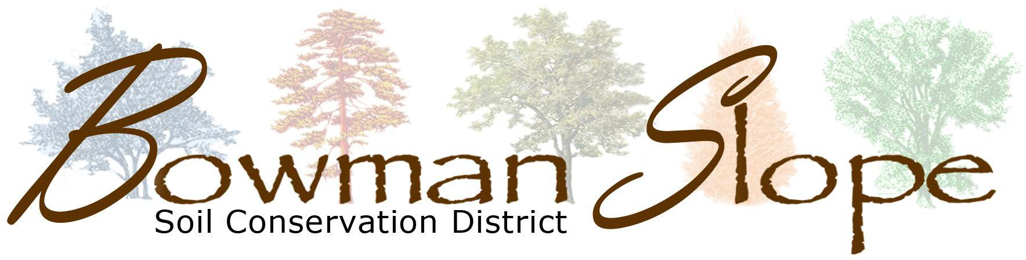
Tree Order
Conservation Grade Trees
12”-18” $2.00 Per Tree
Trees can be ordered individually or in bundles of 25
I will invoice amount due in January.
Ability to fill orders depends on availability of nurseries.

Conservation Grade Trees 2022-2023

# of Trees | Tree Species
 | Almond, Russian
 | Ash, Green
 | Buffaloberry
 | Caragana
 | Cedar, Eastern Red
 | Cherry, Nanking
 | Cherry, Sand
 | Chokecherry, Black
 | Chokecherry, Common
 | Chokecherry, Schubert
 | Cottonwood, Cottonless
 | Cottonwood, Native
 | Crabapple, Common
 | Currant, Golden
 | Dogwood, Redosier
 | Elm
 | Juneberry
 | Juniper, Rocky Mountain
 | Lilac, Common
 | Maple, Amur
 | Oak, Bur
 | Pine, Ponderosa
 | Plum, Native
 | Russian Olive
 | Spruce, Black Hills
 | Spruce, Colorado Blue
 | Willow, Golden
 | Total number of trees ordered

Handplants
Potted
Large Stock /Special Requests
The SCD also has available for purchase: Weed Barrier Fabric
(1.00 per foot for 15’ wide fabric)
(.35 per foot for 6’ wide fabric),
Grow Tubes ($4.00 each)
Thank you for supporting your local soil conservation district!
For office use only
Potted Available
Potted (1 Gallon) $18 Each
Special Requests

# of  Trees | Tree Species
 | Aspen
 | Black Hills Spruce
 | CO. Blue Spruce
 | Eastern Red Cedar
 | Ponderosa Pine
 | Rocky Mt. Juniper
 | Total Potted Trees

Species/ Large Stock
Required Information

Please Mail Orders to:
PO Box 920
Bowman, ND 58623
Orders Due November 1st, 2022
(orders can be submitted after November 1st, but for availability of species from the nurseries the sooner they are submitted the better!)

Name:
Address:
Phone#
Please note: Due to the perishable nature of live plants, variability in planting conditions and care by the customer BSSCD has NO guarantee for survival or growth of any species. We do our best to provide you with quality stock from the time we receive it until the time you pick it up.

Please contact us if you have any questions!
SCD Tree Shed Phone: (701) 523-8733

