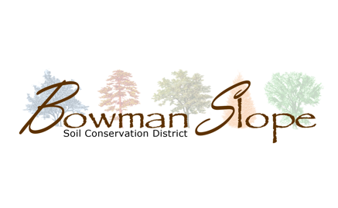
Light Harrow Rental Agreement-Out of County Use

On behalf of myself and my insurers, executors, administrators, heirs, successors and assigns, I hereby:
- Agree to pay the Bowman-Slope Soil Conservation District:
  - $450 Up-Front fee, due before the light harrow is taken, includes:
  - $200 Deposit, which can be applied to bill if no damage is done to the light harrow, $150 Minimum Use Charge for Out of County Users
  - $150 for first full day and every day after that.
- Agree to provide the SCD with an update when I take the light harrow and when the light harrow is returned at the time that it is taken/returned. Failure to do so may result in extra time of use charged on my bill.
- Agree to operate the light harrow accordingly:
  - Review the Field Guide Quick Check: remove transport pin for each wing, drive working speed of 5 mph, use hydraulic cylinder stop blocks to set the field operating position
  - Before roading and/or moving the light harrow, raise the harrow cart and fold wings in, then secure the wings in place with the transport lock pins and hairpin cotter pins
- Agree to grease and do a daily maintenance of the light harrow. I will provide the necessary hydraulic adapter {If needed).
- Agree to pick-up the light harrow at the designated location and tow the light harrow with a tractor or nothing less than a heavy ¾ ton pick-up at a speed not to exceed more than 35 miles per hour.
- Will be responsible for any damages to the light harrow while in my possession. If the light harrow requires any repairs, I will contact the Bowman-Slope Soil Conservation District regarding repairs.
- Agree not to turn too sharply in the field with chains down. This will help prevent damages to the machinery
- Agree to assume the full risk of any injuries, death, damages or other Joss regardless of severity which I may sustain as result of agricultural services provided by Bowman-Slope Soil Conservation District.
- Waive, release, and discharge Bowman-Slope Soil Conservation District, its agencies, officers, employees, and volunteers from any and all liability for death, disability, personal injury, loss of damage to property, or actions of any kind, including unforeseen agricultural production results of any nature which may hereafter accrue as a result of agricultural service provided by Bowman-Slope Soil Conservation District agricultural services.
- Indemnify, save, and hold harmless Bowman-Slope Soil Conservation District, its agencies, officers, employees, and volunteers from any and all claims of any nature, including, cost, expenses, and attorneys' fees which may in any manner result from or arise out of Bowman-Slope Conservation District agricultural services.
- I will completely clean off the chains and completely close the harrow and lock up before travel
- Agree to certify my actual time used with the Bowman-Slope Soil Conservation District staff, for proper billing, when I am done using the light harrow.
WAIVER, RELEASE, AND INDEMNIFICATION
Read this form carefully and be aware that you, by signing, will be waiving and releasing all claims for injury, damage, or unforeseen agricultural productions results you may sustain from the agricultural services provided by Bowman-Slope Soil Conservation District. I am fully aware of and understand the dangers inherent in the agricultural services that are being provided and that they may cause property damage, physical injury, or death to myself or others or may not provide the expected agricultural production results. This waiver, release, and indemnification shall be construed broadly to provide a waiver, release and indemnity to the maximum extent permissible under applicable law. Any modification of this waiver must have written approval by Bowman-Slope Soil Conservation District prior to provision of agricultural services.
I HAVE READ AND FULLY UNDERSTAND THE ABOVE AGREEMENT SPECIFYING MY WAIVER, RELEASE, AND INDEMNIFICATION OF ALL CLAIMS.

Print Name:______________________________ Time & Date Taken:______________________________________
Phone:___________________________________ Estimated Return:_______________________________________
Signature:________________________________ Time & Date Returned:___________________________________

