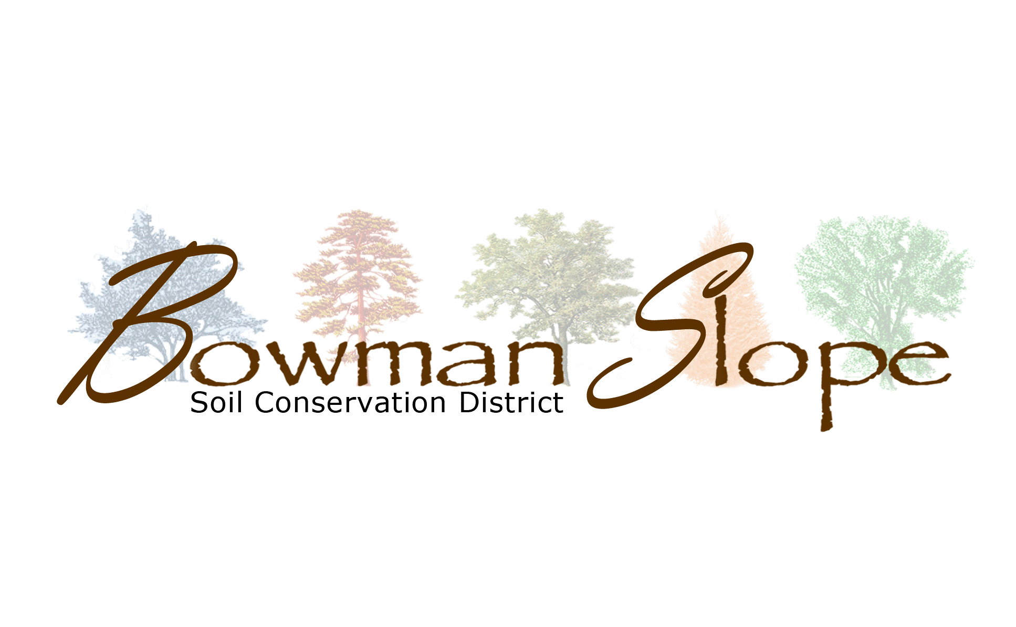
c
Bowman-Slope Soil Conservation District
2025 Annual Report

District Happenings…
The Bowman-Slope SCD’s mission is to educate and assist the public of the Bowman-Slope SCD with natural resource conservation through technical assistance, education, and collaboration with other agencies. The SCD continued educational outreach and cost share programs this year. They hosted the first annual Graze Craze this summer. They also hosted Jolene Brown in October to talk about Succession Planning on the farm or ranch. This year was a big year of planting trees with the help of local high schoolers providing summer help and experiences. The SCD is grateful for all the help that they provide during the tree season. Stop by the SCD Office anytime to visit us and learn more about the conservation practices that we are involved in! Keep reading to see more about the SCD’s activities and programs in 2025!

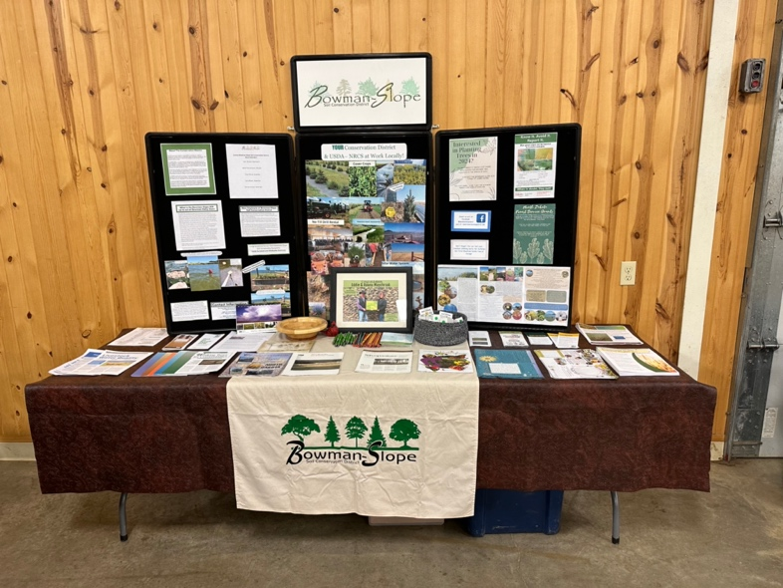

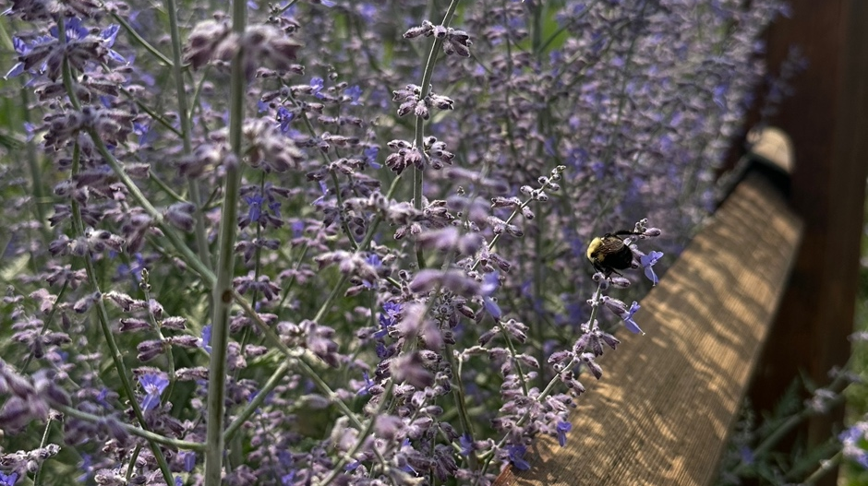
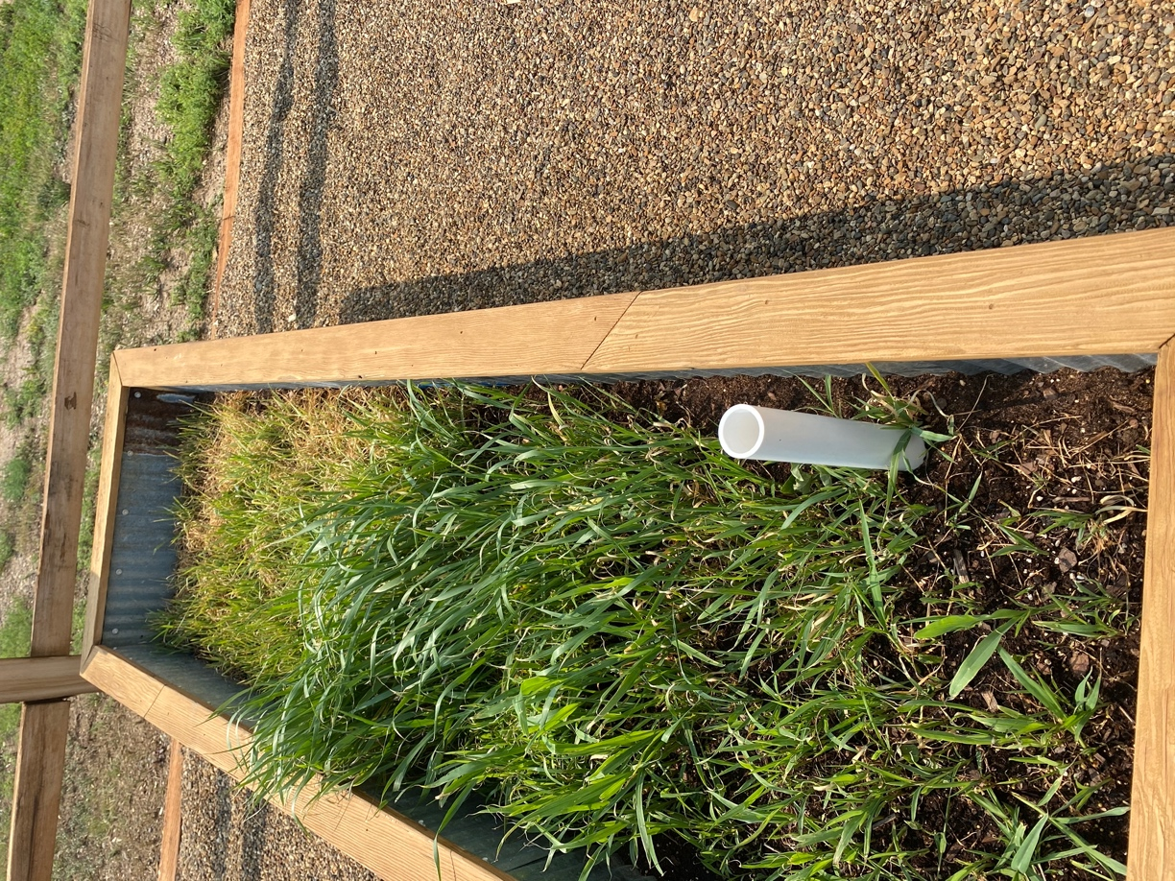
ND Natural Resources Trust

Small Grant
Soil Trees and Bees Education Project
The Bowman Slope Soil Conservation District continued to provide education to the public through the help of the Small Grant Request from the ND Natural Resource Trust. They were able to provide education to the preschool, 2nd grade, 4th grade and the Rhame Elementary.

Education on the Prairie
The Bowman-Slope SCD had partnered up with the Slope County Extension Agent and the Area V Program Coordinator to start working on an education trail at the old Amidon School. The trail is in place and the stations are up. There are perennials, forbs, and trees have all been planted. If you are going through Amidon, stop in at the old school to check it out!
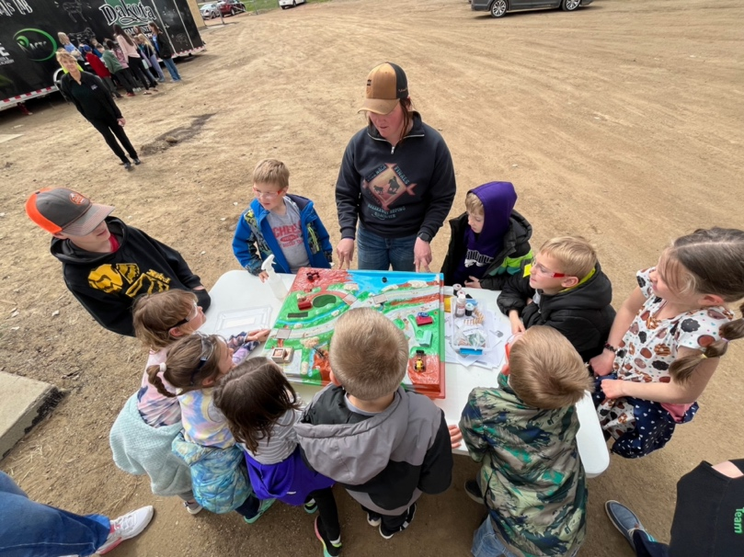
Bowman-Haley Watershed
319 Watershed Project
The Bowman-Slope SCD has been awarded grant funding to improve the water quality in the Bowman-Haley Watershed. These funds will be used to target Non-Point Source Pollution runoff that may be effecting the Bowman-Haley Reservoir. Funds will be used to help producers within the watershed to implement Best Management Practices. These practices will be used to help reduce runoff in the area. These funds will also be used to help provide more education to the community about harmful algal blooms and other water quality concerns. There will continue to be sampling done on the tributaries and the reservoir to help gather data.
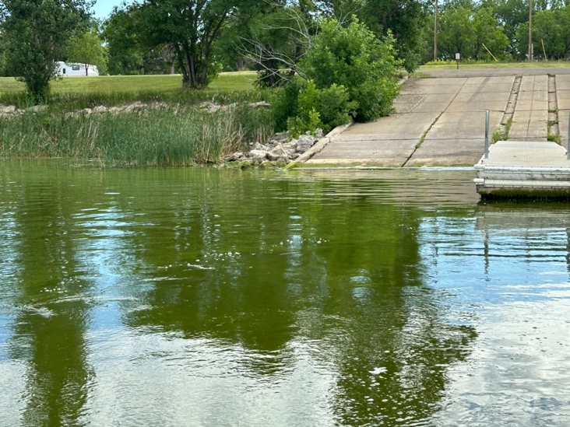
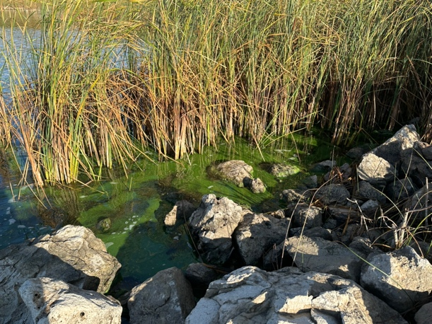
Cost-Share Information/Update

The Bowman-Slope Soil Conservation District have a variety of programs and partners that we can work with to get you some technical and financial assistance for your projects.

The Grazing Resiliency in North Dakota
75% /25% cost-share based on actual cost for water development
60%/40% cost-share based on NRCS rates for fence
North Dakota Prairie Management Toolbox
60%/40% cost-share of current NRCS rate for fence
60%/40% cost-share of actual cost for water development
90% cost-share on invasive woody species removal on grasslands
North Dakota Wildlife Federation
Funding for Juniper removal
Ducks Unlimited
Cover crop and livestock integration project (CCLIP)
75% /25% cost-share of water infrastructure and cover crop seed
60%/$40% cost-share of fencing and portable windbreak panels
15% additional cost-share for wildlife friendly fencing
Smart livestock advancing terrestrial ecosystems (SLATE)
75%/25% cost-share for virtual fence and water developments
60%/40% cost-share for traditional fence

If you have any questions about the cost-share that we have available, or have questions about another cost-share practices, please reach out to Tonya Tysver @ (307) 290-0528.

ND Outdoor Heritage Fund
Cost-Share for Tree Plantings
The SCD has been working with the Outdoor Heritage Fund to offer cost share to producers to install tree plantings. This program has been a 75% cost share for tree plantings that are accepted. The plantings must be at least $2000 in cost and meet the requirements of a wildlife, farmstead, or farmland planting. If this is something that you are interested in, stop in at the office and we will be able to put a plan together.
Bowman Haley Watershed
604b Watershed Project
The SCD has partnered up with United States Geological Survey and North Dakota Department of Environmental Quality to install a real-time monitoring station on Bowman Haley Dam, as well as one of its tributaries, Spring Creek. This information will be used to help understand the harmful algae blooms that are present at the dam. This project has been ongoing since 2021. This was the last year of sampling and analysis for that project, and now the ND Department of Environmental Quality will take over with the USGS to build a model to go into the reservoir to help collect data.
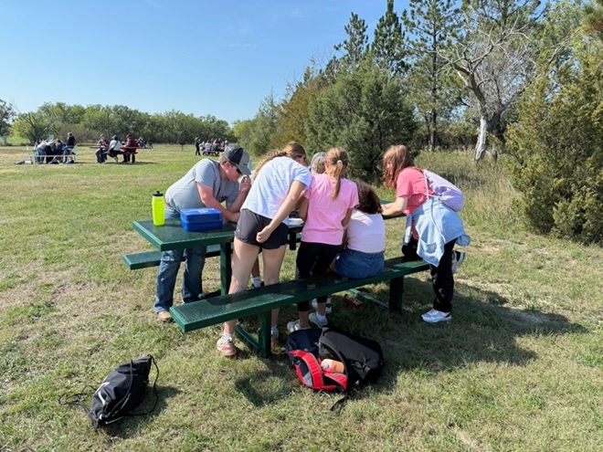
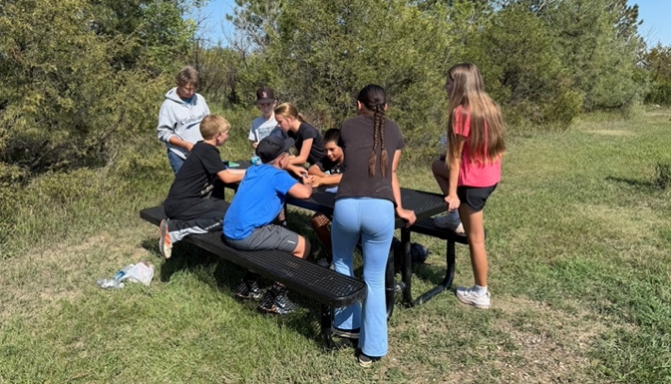
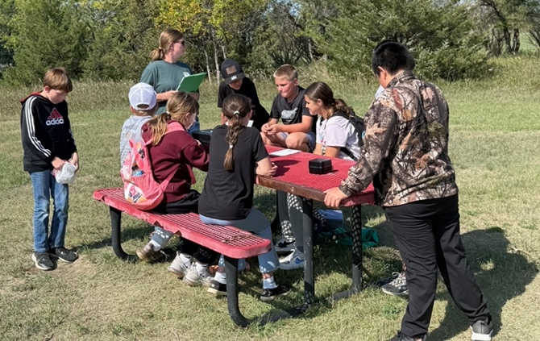
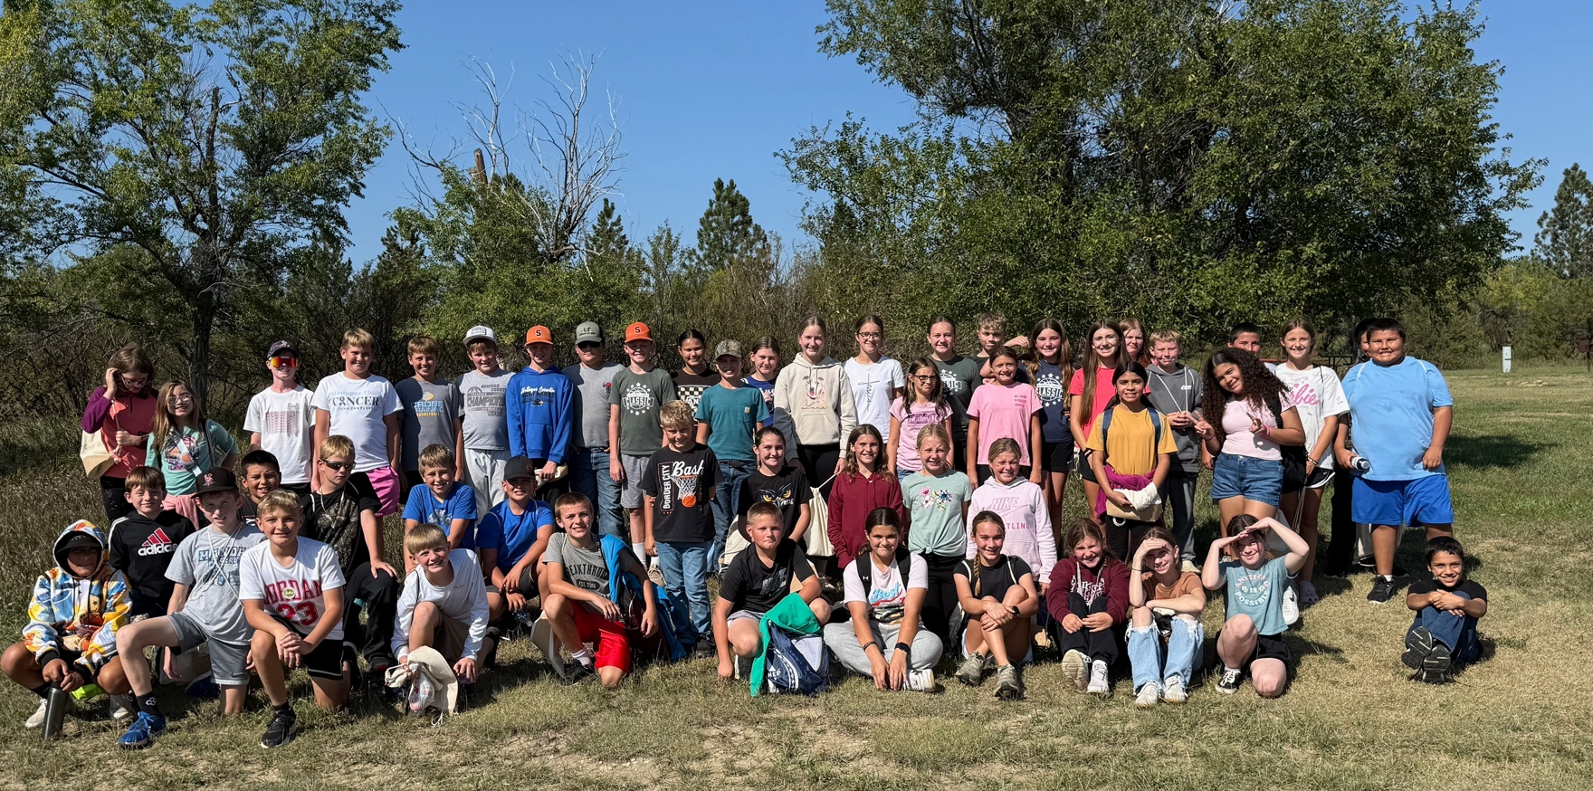
2025 Bowman-Slope SCD
Youth Education Outreach

The Bowman-Slope SCD spent a couple days in the spring going to visit the preschool classes to inform them of the importance of conservation practices that producers do in the area. At the end, we were able to spend time making “grass heads” that the kids were able to take home so they could watch grass grow.

The SCD also spent a day this spring with the 2nd graders from the Bowman County Elementary School. We were able to teach them about life in the soil by letting them go through the soil tunnel and reading them the book “Soil Quilt”.

On the last week of school, the SCD went to visit the 4th graders from Bowman to educate them about pollinators, flowers, and tree species. We ended the session playing a pollinator relay race game to show the kids how monarchs migrate and what challenges they face.

The 6th Graders from Bowman, Rhame, Scranton, and Marmarth were able to join us out at Bowman Haley Dam for our annual Conservation Daze. The kids enjoy this event because they can learn about nature in the outdoors. We had speakers from Scranton FFA, NRCS, NDDEQ, and NDSU.

Bowman FFA was also able to spend a day out at the arboretum to plant trees for the community. Scranton FFA also provided time by making signs to put in front of the trees. We spent a few days going to visit their class and teach them about conservation and our role in helping to preserve our natural resources.
The Bowman Slope SCD is thankful for all the help that they have provided to them throughout the year.

- Cover Crop Acres planted: 2,370.1 acres
- No Till Acres Planted: 19,706 acres
- Tree Plantings: 89,351 feet
- Fence Installed: 93,02 feet
- Grass Seedings: 1,388.9 acres
- Water pipelines: 45,858 feet
- Wells Drilled: 9 no.
- Prescribed Grazing: 50,242.3 acres
- Pest Management: 26,446.3 acres
- Nutrient Management: 8,179.8 acres
- Two Student Scholarships totaling $1500
- Student and Community Education and Outreach
- Livestock Water Quality testing
- Bowman-Haley Dam and Tributaries Water Sampling
- ND Outdoor Heritage Fund Tree Planting and Grazing Resiliency Program cost-share
- Conservation Tree Plantings
- Engineering Services
- Tree sales as well as help diagnosing diseases, identifying tree species, and tree species recommendations.
- Natural Resources Policy Plan Implementation
- No Till Drill Rental Service
- 319 Bowman-Haley Watershed cost-share program

Bowman-Slope SCD & NRCS 2025 Programs and Services
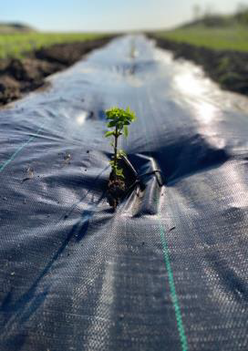
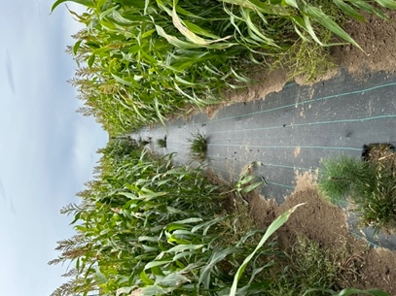
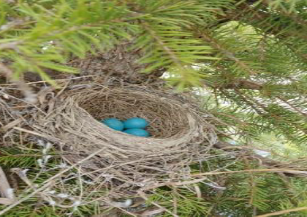

USDA is an equal opportunity provider, employer, and lender.
Bowman-Slope Soil Conservation District
Website: https://www.bowmanslopescd.com
E-Mail: bsscd@ndsupernet.com
Tree Shed: 20 Highway 12 East, Bowman, ND 58623
Tree Shed Phone: 701-523-8733
Conservation District Staff
Sierra Lee- District Manager
Tonya Tysver- District Technician
Conservation District Board Members
Vern Brown Brett Hendrickson
Tony Pierce Tanner Fischer Cory Blaser
Natural Resources Conservation Service Staff
Amanda Berg: Conservation Team Leader
Kraig Motzko: District Conservationist
Tracy Boll: Area Range Management Specialist
Morgan Biberdorf: Soil Conservationist
Rachel McKitrick: Area Biologist

The Bowman-Slope SCD and NRCS look forward to continuing to assist with more conservation practices and education in 2026. Please stop in to chat with us about your operation’s goals and needs anytime! We would love to see what we can do to help you!
We appreciate your support of the Bowman-Slope SCD. We are your local government entity here to serve the people and the natural resources of the Bowman and Slope counties!

